# COMP3500: Resource Allocation Graphs– Exercises (30 Min)

**Exercise 1:** Can you explain this resource allocation graph (a)?

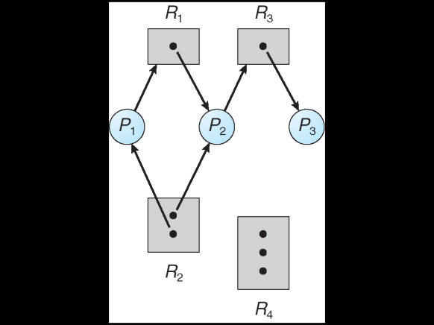 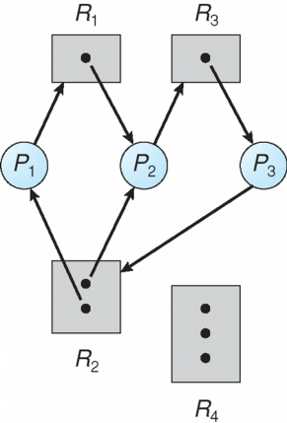

1. **(b)**

**Exercise 2:** Is there any problem with resource allocation graph (b)?

**Exercise 3:** Is there a deadlock in resource allocation graph (c)?

**Exercise 4:** The resource allocation graph (d) has a cycle. Is this a deadlock? Why?

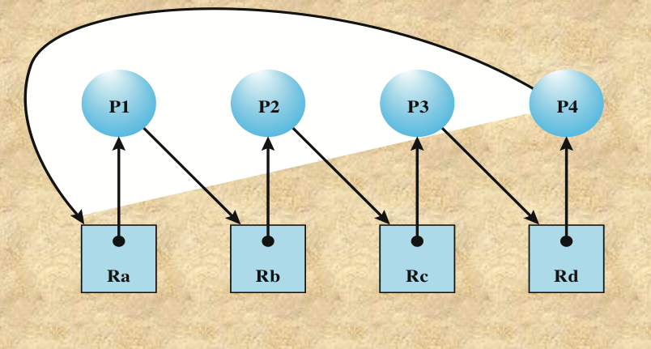 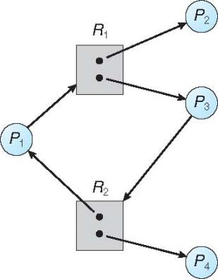

**(c) (d)**

**Exercise 5:** If graph contains no cycles, then __________________

If graph contains a cycle , then

if only one instance per resource type, then _________________

if several instances per resource type, then__________________